# CHAPTER ONE Introduction

**1.1 Background of the Study**

In recent years, technological improvements have benefited the market of easily accessible websites for meeting their consumers' daily demands. Cooking is one such requirement. As a result, recipe websites are proliferating on the internet, overloading the space with extravagant amounts of data. As a result, users may become overwhelmed by the sheer volume and find themselves unable to find the information they were looking for in the first place. (Lemonaki & Beka, 2022).

Millions of cooking recipes are now available online through culinary-sharing sites such as AllRecipes, Cookpad, and Yummly, among others. A recipe is typically provided in a multimedia format, with verbal descriptions of cooking stages paired with culinary photographs to demonstrate the visual result of each step. Liangming et al. (2020)

The concept of online food recipe websites has been around since the early days of the internet which allowed users to search for and share their own recipes with others. In the years since the number of online food recipe websites has grown exponentially. According to a 2018 report by Statista, there were over 8,000 food and recipe websites in the United States alone (Statista, 2018). These websites have become increasingly popular as they offer a convenient way for people to find and share recipes, as well as discover new dishes and cooking techniques.

In addition to traditional recipe websites, the rise of social media has also contributed to the growth of online food recipe sharing. Platforms such as Pinterest and Instagram have become popular places for users to share their own recipes, as well as discover new ones through hashtags and food-related accounts.

Cooking is a process that often becomes a great pastime for many people. The realities of today are such that many cooking schools, chefs, and even amateurs share and offer their services through the web so they need a nice-looking website to deliver their awesome content. Because with content this much attractive by itself, using beautiful cooking website templates will allow you to achieve a real synergy and really rock on the web (Kosych, 2021).

Cooking websites are the perfect way of connecting cooking aficionados and sharing a new experience. it provides plenty of recipes with a user-friendly UI/UX and an editor that anyone can use to customize their culinary palate according to personal needs (Kosych, 2021).

A cooking website is a web resource that is promoted according to information requests on culinary and food topics. Besides presenting your services and sharing helpful information on cooking, you can even monetize your site and get additional money (by contextual advertising, advertising various culinary services, affiliate programs, and other retail marketing strategies) (Kosych, 2021).

**1.2 Statement of the Problem**

Developing the knowledge and motivation for healthy eating early in life remains a challenge. While eating patterns tend to form before and during young adulthood, individuals may have little opportunity to develop their food literacy until they begin to live independently (Colatruglio et al., 2016). This has resulted in the need for fast food by most young adults causing unhealthy eating or eating disorder.

**1.3 Aim and Objectives of the Study**

This project aims to develop a recipe website that provides its users with different types of recipes based on their taste and even in case of need for certain dietary needs in the case of diabetes.

**The objectives are:**

1. An engaging and easy-to-use UI with good UX using HTML.
2. The logic will be handled using JavaScript and the data will be stored using MySQL.
3. Evaluating and verifying the app.

**1.4 Scope of the Project**

The area covered in this research work focuses on recipes not limited to a particular region in the world but based on recipes for certain dietary needs like for diabetes patients.

**1.5 Limitations of the Study**

The platform is limited to recipe guide provision in the format of text without a video tutorial. The study’s scope has also been constrained by time, the researcher's busy academic pursuits severely limited the time allotted for research for this study.

**1.6 Significance of the Study**

The website will offer a convenient and easily accessible way for people to find and share recipes, and it can serve as a valuable resource for individuals and families looking to plan their meals and try new dishes, as well as providing users with certain dietary needs with the options of seeing the food available to them.

**1.7 Project Organization**

The project is divided into three chapters. The outlines are presented below:

**Chapter One: Introduction**

Chapter one summarizes the introductory study on the project work, the background of the study, the statement of the problem, the aim and objectives, the scope of the study, the limitations of the study, the significance of the study, the project organization, and the definition of terms.

**Chapter Two: Literature review**

This chapter focuses on the literature review, and the contributions of other scholars on the subject matter being discussed.

**Chapter Three: Methodology and Design**

This chapter is concerned with the presentation of the results of system analysis and design. It presents the research methodology used in the development of the system to facilitate an understanding and effective future implementation of the system.

**1.8 Definition of Terms**

1. **Recipe:** A set of instructions for preparing a specific dish, including a list of ingredients and their quantities, and the steps involved in cooking or preparing the dish.
2. **Dietary restriction:** A constraint on an individual's diet due to health, cultural, or personal reasons. This can include allergies, intolerances, or preferences such as vegetarian or vegan diets.
3. **Cuisine:** A style or type of cooking characterized by a specific set of ingredients, techniques, and cultural influences.
4. **User interface (UI):** The part of a software application that the user interacts with, including the layout, buttons, and other elements**.**
5. **User experience (UX):** The overall experience of a user interacting with a product or service, including their emotions, perceptions, and behaviours**.**
6. **Search tool:** A feature on an online food recipe website that allows users to locate specific recipes by entering keywords or using filters such as ingredient, cuisine, or dietary restriction.
7. **Rating and review:** A feature on an online food recipe website that allows users to rate a recipe and leave a written review, providing feedback on the recipe and sharing their experiences with it.

# CHAPTER TWO LITERATURE REVIEW



## Introduction

A look at what the programming language and database used the project are and a review of related literature.

## Programming Languages Used

### HTML

HTML stands for HyperText Markup Language. It is a standard markup language for web page creation. It allows the creation and structure of sections, paragraphs, and links using HTML elements (the building blocks of a web page) such as tags and attributes (Astari, 2023).

HTML has a lot of use cases, namely:

* **Web development**. Developers use HTML code to design how a browser displays web page elements, such as text, hyperlinks, and media files.
* **Internet navigation**. Users can easily navigate and insert links between related pages and websites as HTML is heavily used to embed hyperlinks.
* **Web documentation**. HTML makes it possible to organize and format documents, similarly to Microsoft Word.

It’s also worth noting that HTML is not considered a programming language as it can’t create dynamic functionality. It is now considered an official web standard. The World Wide Web Consortium (W3C) maintains and develops HTML specifications, along with providing regular updates (Astari, 2023).

JavaScript

JavaScript is a lightweight programming language that web developers commonly use to create more dynamic interactions when developing web pages, applications, servers, and or even games (Jordana, 2022).

Developers generally use JavaScript alongside [HTML](https://www.hostinger.com/tutorials/html-cheat-sheet) and [CSS](https://www.hostinger.com/tutorials/css-cheat-sheet) The scripting language works well with CSS in formatting HTML elements. However, JavaScript still maintains user interaction, something that CSS cannot do by itself (Jordana, 2022).

The initial versions of the scripting language were for internal use only. After Netscape submitted it to [ECMA International](https://www.ecma-international.org/) as a standard specification for web browsers, JavaScript pioneered the release of ECMAScript (Jordana, 2022).

It was a general-purpose scripting language to ensure web pages’ interoperability across different browsers and devices (Jordana, 2022).

JavaScript has continued to grow alongside new browsers like Mozilla Firefox and Google Chrome since then. The latter even started developing the first modern JavaScript engine, called V8, which compiles bytecode into native machine code (Jordana, 2022).

Today, JavaScript has plenty of frameworks and libraries to simplify complex projects, such as [AngularJS](https://www.hostinger.com/tutorials/what-is-angular), [jQuery](https://www.hostinger.com/tutorials/what-is-jquery/), and [ReactJS](https://www.hostinger.com/tutorials/what-is-react) (Jordana, 2022).

Originally run on the client-side, the JavaScript implementation has branched out to the server-side after the Node.js development ‒ a cross-platform server environment built on the Google Chrome JavaScript V8 engine (Jordana, 2022).

While it caters to web-based programs the most, JavaScript programming features have other implementations in different areas (Jordana, 2022).

## Related Literature

Goel et al. (2022) due to availability of a large amount of cooking recipes online, there is a growing interest in using this as data to create novel recipes. Novel Recipe Generation is a problem in the field of Natural Language Processing in which the main interest is to generate realistic, novel cooking recipes. To come up with such novel recipes, the trained Deep Learning models such as LSTMs and GPT-2 with a large amount of recipe data. And the result is Ratatouille (https://cosylab.iiitd.edu.in/ratatouille2/), a web based application to generate novel recipes.

In Roither et al. (2022) article, a dataset is processed and used for machine learning to classify cuisine style and allergens. The dataset used contains labelling for the 14 major allergen categories. Furthermore, a system is proposed that informs the user about style and allergens in a recipe with the help of a browser add-on. To measure the performance of the proposed system, a user study is conducted where participants label recipes with food allergens.

Bomfim (2022) designed a gameful mobile app to investigate how different technology designs incorporating concepts from food literacy would influence food choices through a situated approach at a grocery store. Then, devised a set of food literacy heuristics in a study involving nutrition experts to guide the design and evaluation of food-related technology. Finally, confirmed the utility of our heuristics with HCI experts to assess how they would use them in technology design.

Lemonaki & Beka (2022) presented in their study the background of recommendation systems and the approach we took to develop both the recommendation systems themselves and the website that supports them, in detail. A dataset that includes fifteen thousand recipes and one hundred and eleven thousand reviews on these recipes was used for the development of the recommendation systems. For those purposes, the authors created three recommendation systems: two content-based and one with collaborative filtering. The first system finds similar recipes based on nutritional values related to the recipe of interest to the user. The second system, using cosine similarity, finds recipes similar to the specific recipe of interest to the user based on ingredients, title, keywords and category. Finally, the third system finds users with similar interests (in terms of recipes) and suggests other recipes. The authors calculated the similarity in terms of interests using the scores users gave to the recipe they evaluated.

Starke et al. (2021) present a methodology to generate natural language justifications that emphasize the nutritional content, health risks, or benefits of recommended recipes. Our framework takes a user and two recipes as input and produces an automatically generated natural language justification as output, based on the user’s characteristics and the recipes’ features, following a knowledge-based recommendation approach.

# CHAPTER THREE PROPOSED METHODLOGY



## Introduction

This chapter covers the analysis models (data flow diagram, sequence, class and entity relationship diagram) of the project and the higher-level solution (programming language) approach used.

## Analysis Models

Analysis models is a technical representation of the system. It acts as a link between the system description and the design model. In Analysis Modelling, information, behavior, and functions of the system are defined and translated into the architecture, component, and interface level design in the design modelling.

### Use Case Diagram

Use-case diagrams **describe the high-level functions and scope of a system**. These diagrams also identify the interactions between the system and its actors. The use cases and actors in use-case diagrams describe what the system does and how the actors use it, but not how the system operates internally.

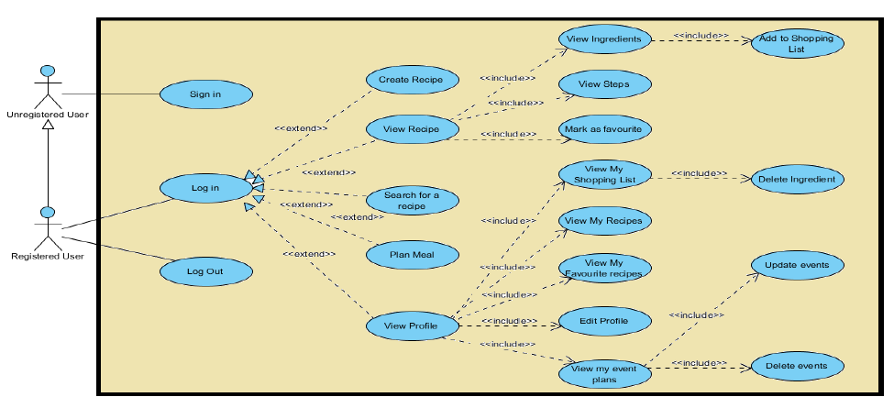

Figure 3.1: Use Case Diagram

### Activity Diagram

Activity diagram is another important behavioral diagram in UML diagram to describe dynamic aspects of the system. Activity diagram is essentially an advanced version of flow chart that modeling the flow from one activity to another activity.

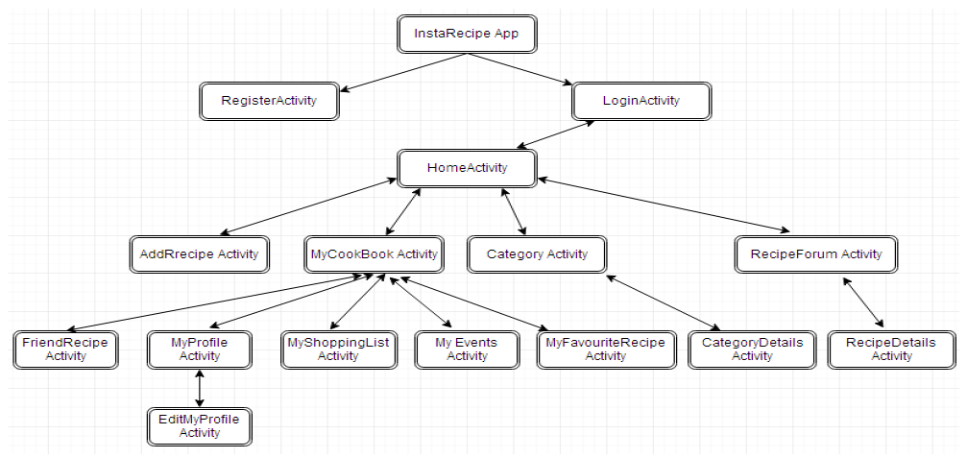

Figure 3.2: Activity Diagram

### Architecture Diagram

Class diagram is basically **a graphical representation of the static view of the system and represents different aspects of the application**. A collection of class diagrams represent the whole system. The name of the class diagram should be meaningful to describe the aspect of the system.

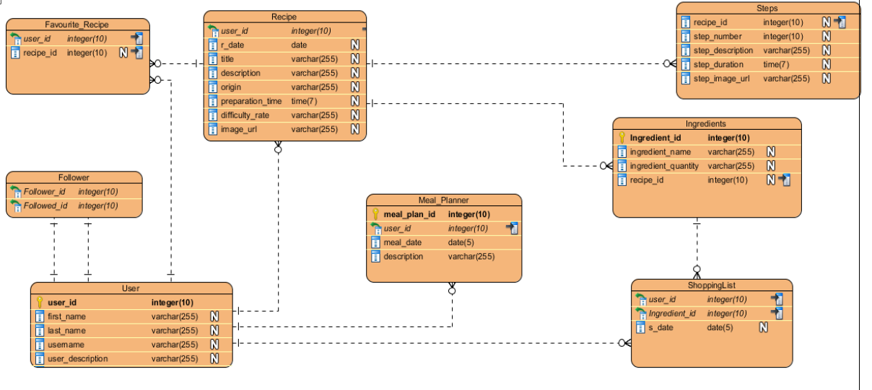

Figure 3.3: Class Diagram

## Programming languages used

* JavaScript
* HTML

REFERENCES

Astari, S. (2023, January 4). *What is HTML? hypertext markup language basics explained*. Tutorials. Retrieved January 5, 2023, from https://www.hostinger.com/tutorials/what-is-html

Bomfim, M. (2022). *A Recipe for Food Literacy: Designing and Evaluating Technologies for Informed Food Choices* (thesis). Association for Computing Machinery, New York.

Colatruglio, Sarah and Joyce Slater (2016). Challenges to acquiring and utilizing food literacy: Perceptions of young Canadian adults". *Canadian Food Studies*, *3*(1), 96-118.

Goel, M., Chakraborty, P., Ponnaganti, V., Khan, M., Tatipamala, S., Saini, A., & Bagler, G. (2022). Ratatouille: A tool for novel recipe generation. *2022 IEEE 38th International Conference on Data Engineering Workshops (ICDEW)*. https://doi.org/10.1109/icdew55742.2022.00022

Jordana, A. (2022, December 21). *What is JavaScript? A basic introduction to JS for Beginners*. Hostinger Tutorials. Retrieved January 5, 2023, from https://www.hostinger.com/tutorials/what-is-javascript

Kosych, D. (2021, June 24). *Cooking website templates - how to make Recipe & Cooking website*. MotoCMS Blog. Retrieved January 4, 2023, from https://www.motocms.com/blog/en/cooking-website-templates/

Lemonaki, E. A., & Beka, K. (2022). *Development Of A Web Application With An Integrated Recommendation System For Recipes* (thesis). Institutional Repository - Library & Information Centre - University of Thessaly, Filellinon και.

Roither, A., Kurz, M., & Sonnleitner, E. (2022). The Chef’s Choice: System for allergen and style classification in recipes. *Applied Sciences*, *12*(5), 25–90. https://doi.org/10.3390/app12052590

Starke, A. D., Musto, C., Rapp, A., Semeraro, G., & Trattner, C. (2021). “Tell Me Why”: Using Natural Language Justifications in a Recipe Recommender System to Support Healthier Food Choices. *Springer Nature*, 1–32.

Pan, L. M., Chen, J., Wu, J., Liu, S., Ngo, C. W., Kan, M. Y., … Chua, T. S. (2020). Multi-modal Cooking Workflow Construction for Food Recipes. In MM 2020 - Proceedings of the 28th ACM International Conference on Multimedia (pp. 1132–1141). Association for Computing Machinery, Inc. https://doi.org/10.1145/3394171.3413765